Appendix A

The Lancashire Skills and Employment
Strategic Framework
2016-2021
Version 6
For Consultation
30/09/2015

Contents

Page

Introduction 3

Lancashire’s Strategic Economic Plan - Delivering the Arc of Prosperity 5

Key Issues in the Lancashire Labour Market 9

Lancashire Skills and Employment Strategic Framework 12
Introduction

The purpose of this Strategic Framework is to make the Skills and Employment system more responsive to the needs of Lancashire, and, in particular, provide the necessary foundations for achievement of the Lancashire Strategic Economic Plan (SEP). It provides a framework for public investment in Employment and Skills activities in the County, and it outlines the direction employment and skills providers need to take to best address need.
This Strategic Framework identifies the key priorities and actions that should be addressed to tackle labour market failure in the County and its localities, and to address the Strategic imperatives of the SEP. It is informed by local needs and opportunities - and challenges providers to be responsive to them. It covers issues of economic inactivity and unemployment; low and basic skills issues; technical skills gaps and skills shortages; apprenticeships; and, higher level skill needs.
The purpose of the Strategic Framework is to:-
- Increase prosperity and economic growth;
- Deliver SEP Priorities;
- Address issues of unemployment and economic inactivity; and,
- Promote social inclusion, social cohesion, and equality and diversity.
The Framework seeks to influence the improvement of service delivery for the county’s employers, young people (14-19) and working age adults. The delivery in scope includes welfare to work programmes; all 14-16 and 16-19 education and training; all apprenticeships; all adult skills and further education; higher education; and, information, advice and guidance services for adults and young people.
Where the LEP Skills Board or Local Authorities have direct authority or a role in particular skills budgets (e.g. European Social Funds (ESF), Growth Deal Skills Capital, 16-19, NEET, IAG etc.), it is intended that the Strategic Framework will inform and underpin the investment decisions made in relation to these budgets. In addition it is expected that the Strategic Framework will influence the utilisation of all post-16 education, skills and welfare to work budgets. Providers making use of these budgets in Lancashire will be invited to set out how their delivery will contribute to achieving the Framework’s priorities. In delivering the Strategic Priorities, the LEP Skills Board and other strategic partners will also work with employers to leverage greater levels of employer engagement and investment in key areas.

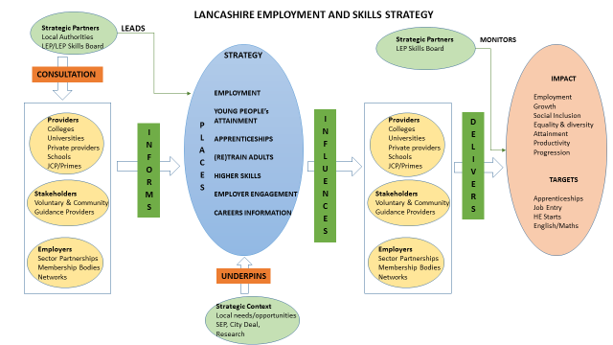

Lancashire’s Strategic Economic Plan - Delivering the Arc of Prosperity

The overarching purpose of the SEP and Growth Deal is to re-establish Lancashire as an economic powerhouse and a national centre of excellence in advanced manufacturing by maximising its clear competitive strengths and capabilities in the aerospace, automotive, energy and health science related sectors. By realising the value of an arc of prosperity, which sweeps across Lancashire, the LEP will harness the power and potential of our national industrial hotspots; our key strategic sites; our key clusters of high value activity; and our internationally recognised centres of excellence in research and innovation. 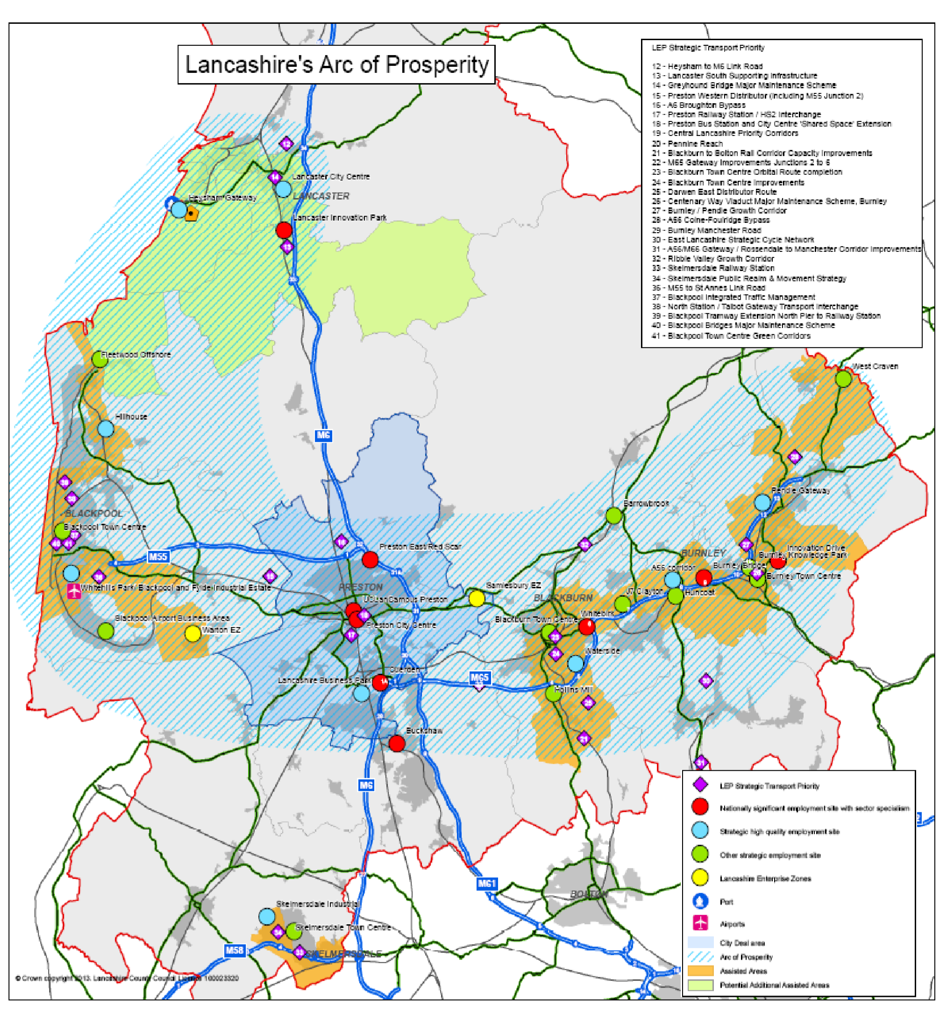

The contribution of Lancashire's visitor and rural economies and heritage assets is acknowledged by the LEP, as is the complementary role these sectors play in delivering the Lancashire Growth Deal. The former is of particular importance to the renewal of Blackpool, where a strengthened visitor economy will be critical to the town's renewal.

Businesses in Lancashire export their goods and services across the world. The area is rightly identified as one of the UK’s strongest export performers, with the likes of BAE Systems’ military air operations playing a central role in delivering the UK’s largest ever international trade deal. Despite this, Lancashire as a location has failed to consistently attract significant new occupiers and investors in recent years. Failure to deliver key strategic sites, a constrained transport infrastructure, and an under-powered strategic marketing capacity, have all contributed to this.

The LEP is now making progress to address these key limitations. Lancashire's Growth Deal will restore more rapidly Lancashire’s ability to compete in the international marketplace for new investment, jobs, learners and visitors.

The Growth Deal is specifically designed to address transport infrastructure issues and establish for the first time a transport investment programme, under the direction of TfL, commensurate with Lancashire's economic and housing growth opportunities and challenges. This investment programme will ensure key locations can fulfil their potential as growth corridors and major industrial, commercial and transport hubs for Lancashire as well as neighbouring economies. It will also maximise the connectivity opportunities afforded by new national and regional initiatives, including HS2, Airport City, Media City UK, Northern Hub, Atlantic Gateway and Liverpool SuperPort.

The SEP recognises that places such as Skelmersdale, in West Lancashire, and Rossendale, in East Lancashire, are equally capable of taking advantage of their adjacency to growth opportunities in neighbouring city-regions, especially in Liverpool and Manchester. The Growth Deal positions the connectivity solutions necessary to maximise these key cross-boundary opportunities.

Partners are working harder to unlock constrained growth opportunities in all parts of Lancashire to create a more balanced economy, especially in terms of re-establishing the local growth trajectories of East Lancashire and Blackpool. The LEP's work to bring forward high quality opportunities consistent with market requirements indicates East Lancashire can grow its existing advanced manufacturing clusters and attract new industrial occupiers, if there are significant improvements in the local transport infrastructure.

The economic success of Lancashire both depends upon, and supports, a new approach to housing growth. Although local partners consider housing regeneration still to be a key issue in certain parts of Lancashire, and especially in Blackpool, the Growth Deal provides the opportunity to bring forward housing growth ambitions in areas that were previously characterised as failed housing markets. The LEP's growth ambition for the Lancashire economy is such that, allied to our own strategic investment plans and those of others, we envisage housing build completion rates returning to levels not seen since the mid-1990s.

The arc of prosperity currently generates around 75% of Lancashire's wealth and provides the primary focus of our economic and housing growth plans. The SEP therefore concentrates economic activity and Growth Deal investment in this arc.

In spatial terms, the arc of prosperity captures:

The importance of Lancaster as a major location for economic and housing growth, underpinned by its world-class research intensive university, a renewed city centre, and the prospect of further growth as an energy centre and port serving Lancashire and the wider region;

In Wyre and Fylde the truly global excellence of an established base of growing polymer science, nuclear and renewable energy focused companies including AGC, Victrex and Vinnolit;

Blackpool remains one of the UK's leading visitor destinations, but it is vital this competitive advantage is further strengthened and its social and economic renewal accelerated;

The two Lancashire EZ sites at Samlesbury and Warton that are exclusively focused on the growth of advanced manufacturing;

Central Lancashire is home to some of the UK's leading automotive companies, including supply chain clusters with companies such as Clean Air Power and Torotrak, and Tier 1 OEM companies including PACCAR (Leyland Trucks);

Preston, the county's largest urban centre, the focal point of our City Deal 10-year infrastructure and development programme and home to UCLan; and

The M65 Growth Corridor which forms the economic spine of East Lancashire, and includes, Blackburn as its key gateway location, Burnley, the UK's most Enterprising Area, and Pendle, which has the largest concentration of employment in advanced manufacturing in England.

The arc of prosperity clearly signals where the new jobs and housing growth in Lancashire will be generated, supported by key economic and transport interventions. More than 90% of the county's forecast additional employment opportunities will be located on sites, and at locations, within the arc. Almost all of the county's large single-site housing development schemes are also within the arc. Delivering the arc of prosperity is central to achieving the LEP's strategic vision, providing a platform from which the SEP's strategic objectives and priorities can be clearly articulated.

The skills and employment system is a key cross-cutting enabler, underpinning sector development and growth, inward investment and the development of employment sites and the Enterprise Zones, individual business growth and social mobility.
Key Issues in the Lancashire Labour Market

Critical Constraints
The Lancashire workforce is ageing, as it is elsewhere in England, and combined with modest population growth, this presents the biggest challenge to the LEP meeting its economic targets. Four factors - the current population size, demographics, economic activity and skills profile will make it more difficult for Lancashire to attract the inward investment needed to support the employment targets set out by the LEP. The skills and employment system can make a real impact on two of those factors – economic activity and skills.
A lower proportion of employment in the current business base in higher level occupations than nationally, will make it difficult for employers to recruit skilled workers, particularly for a number of the priority sectors. Reskilling the existing workforce will go some way to addressing this.
Although a significant number of young people from Lancashire go on to higher education, many young people are not returning, and the low numbers in the workforce aged 21-34 years old is a serious weakness in the workforce profile.
In the future, employers are likely to find it difficult to recruit higher skilled and experienced personnel, and increasing demand for construction is likely to lead to more severe skills shortages in skilled trades, with the potential for the displacement of skilled workers from other sectors.
There are major challenges in creating new employment opportunities in East Lancashire. There are also considerable challenges with regard to Blackpool, Fylde and Wyre.

Employment Growth and the Lancashire Workforce
Growth sectors in the Lancashire economy will create circa 45,000 jobs over the next ten years, and this will increase to over 55,000 if the LEP’s ambitions for economic growth are met. In terms of recruitment and skills to support this employment growth:
- A marked increase in construction employment is likely to be inhibited by skills and recruitment challenges.
- A large proportion of the recruitment for the forecast increase in logistics and distribution, the visitor economy and leisure can be met by local residents supported by relevant occupational training.
- The growth in business and professional services and ICT related business may be affected by a limited pool of labour of well qualified younger people, and this may have an impact on inward investment.
The challenges facing companies recruiting for new jobs will be exacerbated by the need to replace existing workers as they retire, change jobs or leave the labour market. Replacement demand will create much greater requirements for training provision than absolute employment growth, much of it in higher level occupations.
The economic forecasts suggest that manufacturing employment will decline by some 10,000 jobs over the next ten years. Initiatives are underway to ensure this does not happen and that manufacturing sub-sectors with the potential to grow are fully supported. This will require:
- New inward investment linked to Lancashire manufacturing specialisms and supply chain.
- The continual upskilling of the workforce.
- A long term programme to bring new apprentices and graduates into the industry.
Given the need for Lancashire to address the ageing of its workforce and to stop the talent drain of younger workers, Lancashire needs to develop best in class apprenticeship and graduate retention programmes.
The overall competitiveness and sustainability of the Lancashire economy is linked to a wider move to a higher skilled and more productive workforce in both manufacturing and the service sector. This will require, at every level, a better educated and qualified workforce, with both life and vocational skills.

Employability
The Lancashire economy currently has too few jobs to provide the employment opportunities to increase employment rates to a level which would significantly raise low household incomes in many communities. A considerable number of people are without employment in Lancashire, and this number has been affected by the slow employment recovery compared to other parts of England. As jobs growth begins to take hold in the County, linking those out of work with these opportunities may help to decrease economic inactivity levels.
A lower employment rate, particularly amongst certain age groups (and older people) and the doubling of unemployment since the onset of recession, with 50,000 currently unemployed, presents a challenge in an economy where employment growth has been limited recently. As the employment recovery picks up in the County, it is imperative that these increasing opportunities are linked to local people who can benefit from them.
While the workforce is ageing, many people will need to remain in employment for longer due to changes in pension arrangements. This could indirectly lead to fewer employment opportunities for young people, unless new jobs are created in the economy. Successful delivery of the LEPs growth plans will be fundamental.
There is a strong link between qualifications and employment, and too many people, including those affected by Welfare Reform, have qualifications below Level 2. These people are vulnerable to becoming trapped in low-paid and insecure employment, leaving some communities experiencing low incomes and multiple deprivation. Adults achieving employment-linked qualifications at Levels 2 and 3 provides a route to more secure employment options.
There is a need to improve the educational performance of school students in many parts of Lancashire. With current attainment levels, too many school students will be unable to take up the employment and training opportunities in the sectors which will create new jobs.

Skills and Employment Provision
Lancashire has a number of highly regarded Further Education Colleges, private providers and Higher Education Institutions, providing substantial work-related education and training each year to young people and adults. While provision attempts to match market demand, there are some areas where increased provision could be considered.
Considerable numbers each year are provided with life and work skills, although workplace learning opportunities are limited. Apprenticeships continue to provide work based training opportunities, although again numbers are limited, and without further incentives it is not clear if employer participation can be increased substantially, or if a significant number of young people with the required capabilities and attitudes can be attracted into apprenticeships as a vocational alternative to higher education.
The Work Programme is the largest back to work programme in Lancashire, although less than one in four of the substantial number of participants successfully attain a job outcome.

Priority Issues
The provision of training needs to take account of both the challenges in supporting employment growth and the need to strengthen the existing business base through a better skills workforce. The emerging priorities are:
- Young People’s attainment: improving the attainment rate of schools students to above the national average, with a focus on those schools where students are seriously lagging behind.
- Careers Advice and Guidance: provision of advice and guidance to young people, underpinned by robust labour market intelligence, highlighting the career opportunities in the County and employability in a changing economy.
- Apprenticeships and vocational training: increasing the number and quality of apprenticeships and encouraging greater levels of provision at a higher level, reaching more employers in sectors with high replacement demand and growth.
- Graduate and Higher-level skills retention: developing new and innovative mechanisms including increasing internships and graduate placements across the Lancashire business base, increasing the number of workers with higher level skills.
- Construction: given the need to complete major infrastructure works and increase residential development, develop new initiatives to address requirements and skills changes in construction and increase the number of partnerships in skilled trades.
- FE and Skills Provision: working with Further Education Colleges, private providers and employers to target vocational training opportunities at areas of high replacement demand and future employment growth.
- Employer engagement: there is a need to increase employer engagement in skills, and encourage greater commitment to workforce development, as well as encouraging employers to work with education providers to influence vocational provision.
- Employability: there is a need to increase efforts to link young people and those seeking employment with the regular opportunities made available through replacement demand, and tackle employability issues before they become entrenched by reducing the number of young people becoming NEET, and working with those at risk of redundancy to re-train or transfer their skills to other sectors / employers.
- Work Programme: Lancashire needs a more effective Work Programme capable of generating higher than average outcomes for local residents.

Lancashire Skills and Employment Framework

The Lancashire Skills Board commissioned a range of studies to bring together a robust evidence base to develop the Lancashire Skills and Employment Framework. This included: a comprehensive review of skills and employment issues in Lancashire (summarised in the critical issues section above); six sector studies focusing on areas of high replacement demand and growth potential (Advanced Manufacturing; Energy and Environmental Technologies; Creative and Digital; Health and Social Care; Finance and Professional Services; and Visitor Economy) and, in addition a skills and employment study commissioned by the City Deal Executive highlighting the critical skills and employment issues in the Construction Industry.
The framework draws together the key priorities and objectives from the range of studies, identifying common themes and issues. The framework is structured into 4 themes: Future Workforce, Skilled & Productive Workforce, Inclusive Workforce and An Informed Approach. These themes are underpinned by a number of key objectives, plus a common set of outcomes for the framework as a whole. Page 13 provides the overview of the framework by theme. The themes and objectives articulate the priorities for Lancashire.
The themes and objectives are broken down further into a number of actions on pages 14-17.
It is intended that the Strategic Framework will inform and underpin the investment decisions made in relation to discretionary funding (for example, ESIF funding and Growth Deal Skills Capital) and influence the use of mainstream skills and employment budgets. Providers making use of these budgets in Lancashire will be invited to set out how their delivery will contribute to achieving the Framework’s priorities. In delivering the Strategic Priorities, the LEP Skills Board and other strategic partners will also work with employers to leverage greater levels of employer engagement and investment in key areas.
An action within the framework is to establish Sector Skills Development Partnerships. This will evolve from the stakeholders involved in the development of the sector evidence bases and allied action plans. The Sector Skills Development Partnerships will oversee the implementation of sector specific action plans which will feed into the achievement of the actions and objectives detailed in the Framework.

Lancashire Skills and Employment Framework – Overview
 | Theme | Objectives |  |  |  | Outcomes
 | Future Workforce | - To increase school attainment levels in areas of concern in Lancashire through the 'Careers Inspiration' agenda.  - To co-ordinate and improve the Careers Education, Information, Advice and Guidance (CEIAG) offer to people in schools, colleges, providers and universities and increase engagement with STEM subjects, vocational pathways and routes into key LEP sectors and areas of high replacement and growth demand.  - To improve vocational pathways from classroom based provision to higher level work-based provision.  - To increase graduate retention in Lancashire by improving engagement with employers during and after programmes of learning (e.g. work based projects, placements and internships) and by improving the attractiveness of Lancashire to ambitious and aspirational graduates.  - To reduce current skills shortages (teachers, tutors and lecturers) by increasing engagement of employers in co-delivery and sharing of staff across providers.  - To improve employability and enterprising skills, attitudes and behaviours across the education journey.  - To improve and ensure that post-16 education and learning facilities are fit-for-purpose and that responsive and flexible approaches are taken (e.g. blended learning). |  |  |  | - Reduction in Lancashire unemployment and NEET figures.  - Less reported vacancies / skills shortages in key LEP sectors and areas of high replacement demand and growth.  - More Lancashire residents skilled at Level 3 and above.  - Increased social mobility in disadvantaged areas.  - Improved school attainment levels in under performing schools across Lancashire.  - A greater number of graduates choosing to work in Lancashire.  - Less reported skills shortages in providers (teachers, tutors and lecturers).  - Greater number of apprenticeships at L3 and above.  - Greater number of employers offering graduate level jobs and investing in skills.
 | Skilled and Productive Workforce | - To increase the number of apprenticeships (including higher level and degree) in areas of high replacement demand and growth.  - To increase the number of companies in Lancashire offering graduate-level and professional jobs, and attract new businesses likely to recruit higher skilled people.  - To increase the number of employers undertaking workforce/succession planning and investing in skills.  - To improve the provision of sector-specific training to tackle skills shortages in LEP priority sectors.  - Raise the capability of SMEs to grow through leadership and management interventions.
 | Inclusive Workforce | - To improve the employability and skills of unemployed adults and NEET young people to enhance job prospects, particularly in areas of high replacement demand and growth.  - To provide relevant labour market information (LMI) and CEIAG to support decision making.  - To facilitate routes into employment through sector specific initiatives, for example, Sector Based Work Academies.
 | An Informed Approach | - To create a 'skills observatory' for Lancashire that will maintain the skills and employment evidence base and an oversight of relevant policy.  - To facilitate 'Sector Skills Development Partnerships' that will drive the implementation of sector specific action plans.  - To connect and collaborate with other LEP areas to influence 'mainstream' provision (e.g. CEIAG), collaborate, and to share good practice.
Future Workforce (FW)
Actions (aligned to the objectives in the overview) |  |  |  | Sector Priorities | Ownership |  | Mechanisms
1a Inspire young people through industry role models, materials and activities to motivate them to achieve higher attainment levels.  2a. Gain an overview of CEIAG activity across Lancashire to gain an understanding of strengths and weaknesses and areas requiring intervention.  2b. Work with the Careers and Enterprise Company, the National Careers Service (NCS) and local CEIAG providers to increase interactions between employers and schools and post-16 providers in sectors with high replacement demand and growth through a range of activities.  3a. Providers to work with employers to ensure that curriculum is fit for purpose and to improve vocational and non-traditional pathways (e.g. higher level apprenticeships).  4a. Increase the number of Lancashire-based businesses offering work based projects, placements, internships and KTPs to Lancashire (under) graduates and graduate level vacancies with good terms and conditions.  5a. Work with the Sector Skills Development Partnerships (SSDPs) to develop models for increasing co-delivery by employers, industry assessors and the sharing of staff.  6a. Work with the Careers and Enterprise Company to develop and implement the 'Enterprise Passport' to provide a mechanism for recognising employability/enterprise skills.  6b. Map the enterprise education journey with view to reinforcing curriculum and activities which develop enterprising skills, attitudes and behaviours.  7a. Invest Growth Deal (skills) capital in projects which will enhance Lancashire's education and learning facilities in-line with employer demand.  7b. Establish a Lancashire wide forum to accelerate the use of blended learning, including the use of on-line learning, simulation and virtual reality. |  |  |  | All sectors raised the need to promote their industry to young people, in terms of breadth, career / progression pathways, to break myths and to promote current and future opportunities in Lancashire. Employer engagement should thus be targeted at all key sectors. Advanced Manufacturing, Energy and Environment and Construction raised the need to increase the number of students choosing STEM subjects in school / post-16.  Creative & Digital (digital), Energy & Environment, Advanced Manufacturing and Construction specifically raised the need to attract females to their industries; activities should thus be integrated into 1b and 2a to address this issue.  Graduate attraction and retention was cited as a particular issue for all sectors apart from Visitor Economy.  Visitor Economy, Energy and Environment, Finance and Professional Service and Creative and Digital specifically raised the need to improve work readiness, softer skills and enterprising skills.  The need to invest in up-to-date equipment and technology to ensure learning is fit-for-purpose cut across a number of sectors. A Hotel School was also recommended by Visitor Economy. | 1a-2b: Lancashire Skills Hub, NCS, SSDPs, CEIAG providers, Schools, Sixth Forms, Colleges and Providers, Employers.  3a: Skills Providers, Employers.  4a: Lancashire Higher Education Institutions (HEIs) and FE Colleges offering Higher Education, Employers.  5a: SSDPs, Employers, Skills providers.  6a-6b: Lancashire Skills Hub, NCS, Schools, Colleges, HEIs.  7a: Lancashire LEP and Lancashire Skills Board.  7b: Lancashire Skills Hub, Colleges, Providers and HEIs.
Skilled and Productive Workforce (SPW)
Actions (aligned to the objectives above) |  |  | Sector Priorities |  | Ownership |  | Mechanisms
1a. Drive the engagement of employers in the development of apprenticeship standards to increase the number of relevant L3+ (advanced, higher and degree) apprenticeships on offer in Lancashire.  1b. Increase capacity in post-16 providers and universities to offer L3+ apprenticeship routes and develop robust progression routes from classroom based vocational provision.  2a. Increase the attractiveness of Lancashire for 'growth' companies, supply chain development, and ambitious graduates and professionally qualified people.  FW 4a. Increase the number of Lancashire-based businesses offering work based projects, placements, internships and knowledge transfer partnerships to Lancashire (under) graduates and graduate level vacancies with good terms and conditions.  3a. Integrate a workforce/succession planning service into the Lancashire Growth Hub, alongside a skills brokerage service to increase the number of (new) employers investing in skills.  3b. Consider the development of a 'skills pledge' model to encourage the engagement of employers.  4a. To integrate specific sector skills needs into programmes such as 'Skills Support for the Workforce' and feed intelligence into the supply side to influence curriculum.  5a. Provision of a Lancashire wide leadership and management programme targeting owner managers of SMEs, aimed at improving leadership capacity and innovation / creativity to enhance business growth. |  |  | All sectors stated the need to increase the number of advanced, higher and degree apprenticeships to support progression and retention. Health and Social Care and Visitor Economy also encouraged the use of traineeships as a route into apprenticeships.  Advanced Manufacturing and Energy and Environmental emphasised the need to support the development of the supply chain.  Graduate attraction and retention was cited as a particular issue for all sectors apart from Visitor Economy.  Advanced Manufacturing, Health and Social Care, Visitor Economy and Energy and Environment encouraged employer engagement through a brokerage service and/or a skills pledge model.  A number of sector specific needs need addressing including: care certificate, health and care interdisciplinary training, advanced IT and software skills, cyber-security, cloud-based computing, QA, data science, energy and environment-related engineering skills, sales and marketing, project management, social media, customer service and other technical skills.  Creative and Digital, Visitor Economy and Energy and Environment cited the need to improve leadership and management skills and entrepreneurialism. Finance and Professional Services focused on the need to support the growth of family owned businesses through succession planning, mentoring and the use of non-executive directors. |  | 1a: SSDPs, Employers, Lancashire Skills Hub, Skills Providers and HEIs.  1b: Skills Providers and HEIs.  2a: Lancashire LEP.  FW 4a: Lancashire Higher Education Institutions (HEIs) and FE Colleges offering Higher Education, Employers.  3a: LEP Business Support Management Board, Lancashire Skills Board, Lancashire Skills Hub, Lancashire Growth Hub.  3b: Lancashire Skills Hub, Lancashire Growth Hub.  4a: Lancashire Skills Hub, Skills Providers.  5a. Lancashire Skills Hub, Lancashire Growth Hub, Skills providers and HEIs.

Inclusive Workforce (IW)
Actions (aligned to the objectives above) | Sector Priorities | Ownership | Mechanisms
1a. To facilitate improvement in Work Programme outputs by correlating activity with areas of high replacement demand and identifying interventions which would be complimentary and improve outcomes.  1b. Employability and skills development programme incorporating CEIAG for adults not in work and not claiming benefit and those at risk of redundancy (targeting individuals outside of the Work Programme and mainstream provision).  1c. Employability and skills development programme incorporating CEIAG targeting NEET young people.  1d. 'Hard to reach' programme(s) aimed at the disadvantaged and the furthest from the labour market (incorporating an escalator model which will feed into 1a, 1b, 1c as appropriate or other relevant activity which will provide a pathway into learning or work).  1e. Incorporate the Social Value Act (2012) into LEP capital programmes to create skills and employment opportunities aimed at the unemployed, disadvantaged and NEET.  3a. Sector specific 'ready for work' programmes building on models like Sector Based Work Academies, targeting areas of high replacement demand and inward investment opportunities.  3b. Review viability of a 'Wheels to Work' scheme for rural areas of Lancashire, building on good practice in Cumbria. | Health and Social Care and the Visitor Economy highlighted the potential for retraining and sector-based approaches to fill high levels of replacement demand and growth. The significant growth projections in construction would also apply.  Visitor Economy highlighted the benefits of the 'Wheels to Work' programme to individuals working unsociable hours. | 1a: Lancashire Skills Board, DWP, Work Programme Providers.  1b: Lancashire Skills Board, DWP, JCP, Providers.  1c: Lancashire Skills Board, Local Authorities, Providers.  1d: Lancashire Skills Board, Local Authorities, Providers.  1e: Lancashire Skills Board, Growth Deal Management Board, City Deal Executive, recipients of capital funding.  3a: Lancashire Skills Board, Providers, SSDPs.  3b: Lancashire Skills Board, Lancashire Skills Hub.

An Informed Approach (IA)
Actions (aligned to the objectives above) | Sector Priorities | Ownership | Mechanisms
1a. Development of the Lancashire Skills Hub as a hub of intelligence in regard to relevant policy and LMI for local stakeholders, and to influence and position Lancashire in the Local Enterprise Partnership (LEP) network and nationally.  1b. Use of the Skills and Employment Framework and related intelligence to influence, prioritise and direct the use of mainstream and discretionary funding (e.g. ESIF, Growth Deal, Area Review, devolution agenda).  2b. Development of 7 Sector Skills Development Partnerships to oversee, facilitate and deliver sector action plans in Advanced Manufacturing, Energy and Environment, Creative and Digital, Visitor Economy, Health and Social Care, Finance and Professional Services and Construction.  3a. Create relationships and collaborations with other LEP areas facing similar challenges to influence mainstream provision lobby and influence and develop collaborative projects. | Cross sector call to maintain local labour market intelligence and oversight of policy to drive local provision and to influence / position nationally.  Proposed that Sector Skills development Partnerships are put in place to drive sector-focused activity, building on the steering groups which oversaw the initial baseline studies and the development of sector action plans. | 1a. Lancashire Skills Hub, Representative Groups.  1b. Lancashire Skills Board, Lancashire Skills Hub, Representative Groups.  2b. Lancashire Skills Hub, SSDPs.  3a. Lancashire LEP, Lancashire Skills Board, Lancashire Skills Hub, Representative Groups.

http://www.lancashirelep.co.uk/media/8856/LEP-strategic-economic-plan.pdf

